Making IT Happen: Standards

LiTiRi: Data Modeling

Version 1.0

Louis Smith

Revision History
Date | Version | Description | Author
16 April 2015 | 1.0 | Initial Draft | Louis Smith

Table of Contents
Section Page
1. Overview 1
1.1 Brief Description 1
2. Maturation of the Model with Phases of the Project 1
2.1 Initiation 2
Figure 2-1. Example ERD 2
2.2 Business View (Logical Data Model) 3
Figure 2-2. Example Logical Data Model 3
2.3 Normalization 4
2.3.1 Atomic 4
2.3.2 Non-Repeating 4
2.3.3 Key Dependent 4
2.4 Usage Table 5
Figure 2-3. Example Usage Linking 5
2.5 Implementation View (Physical Data Model) 6
2.5.1 Table Names 6
2.5.2 Column Names 6
2.5.3 Data Types 6
2.5.4 Size and Precision 6
Figure 2-4. Example Physical Data Model 7
3. Reference Materials 8
3.1 Class words Reference Chart 8
Figure 3-1. Class words Reference 8
3.2 Verbalization Test 9
4. Attribute Naming Process 10
4.1 Classify and Class Word 10
4.2 Reduce 10
4.3 Determine Qualifier 10
4.4 Determine Prime Word 11
4.5 Reduce 11
4.6 Abbreviate 11
4.7 Upper Case 11

LiTiRi: Data Modeling

Overview

Brief Description
The purpose of this document is to introduce the reader to our lightweight approach to modeling data across an IT project. Our primary goal is to utilize our Elegance of Simplicity pattern to establish a clear, concise, and easily understandable process and related standards for Data Models and how they are created during a project.

Maturation of the Model with Phases of the Project
As a project continues down its development time-line from Needs, to Analysis, to Design the model matures as well. The initial level of the model (ERD - Entity Relationship Diagram) contains very little information about the artifacts the business uses; the second level (LDM - Logical Data Model) contains all the information the business needs to know about each of the artifacts; and the third level (PDM - Physical Data Model) contains all the information the developers need to actually create the database to hold the information.
This process has been nearly ruined by several vendors rolling out products to support design and development which “lock in” their technology early in the process. I have seen ERDs that were so fully fleshed out that the database could have been easily created from them. That isn’t their purpose – there are 3 distinct models with 3 very distinct titles and very distinct usages. Remember that.

Initiation
At the project initiation phase, we are trying to establish the list of business items which must be handled by the users, and how those items relate to one another. This process does not care about the items per se; only about how they interact, relate, and rely on each other.
This is modeled in what is commonly known (and universally misunderstood) as an Entity Relationship Diagram. An ERD is really about the relationships far more than about the entities.
Hence, the diagram will be of "empty" boxes with names (people, addresses, form letters) and lines between those boxes with how they relate. Here is an example:

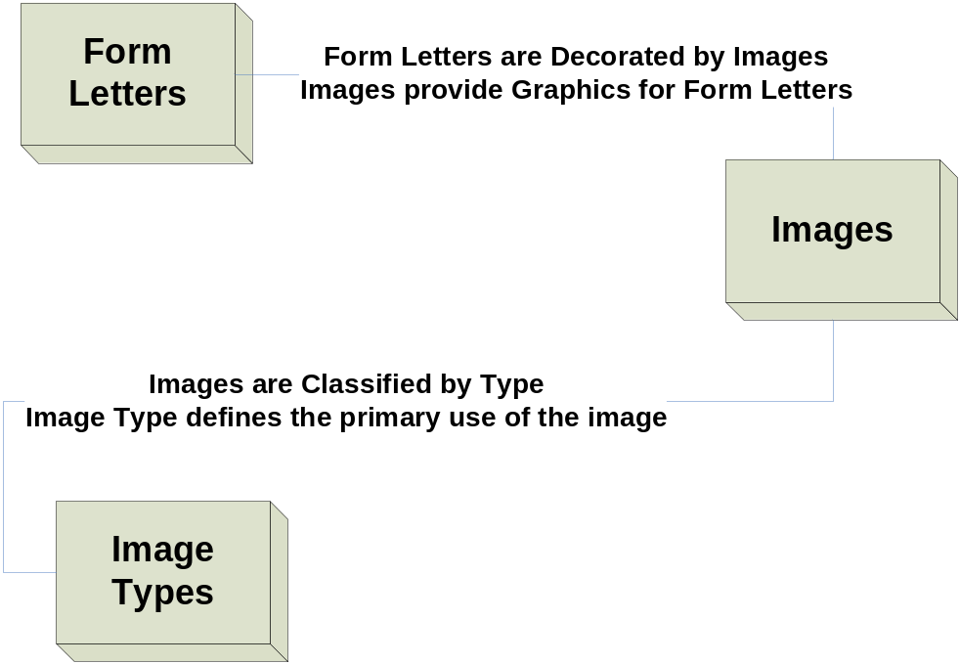

Figure 2-1. Example ERD

The "rules" are fairly simple:

1) non-attributed. Name of the entity only.
2) non-circular relationships
Fail: "is a / has a"
Pass: "Addresses define mailing, shipping, or physical locations"

Business View (Logical Data Model)
The Business View is the next part that the Analysts define with the users. This must use their terminology as it is critical to the success of the project that all business personnel understand this implicitly - there can be no confusion at this point. At this stage, the "details" are captured, but are NOT part of the model. No "technical speak" is allowed.
Fail: "Birth_Date"
Pass: "Employee Date of Birth"
The "mandatory" database fields should be left out UNLESS they have a BUSINESS meaning. These fields are typically Begin/End Date; Created by and Modified by datum used for data purposes only. When the business users control the Begin/End date, then they should be shown on the LDM.

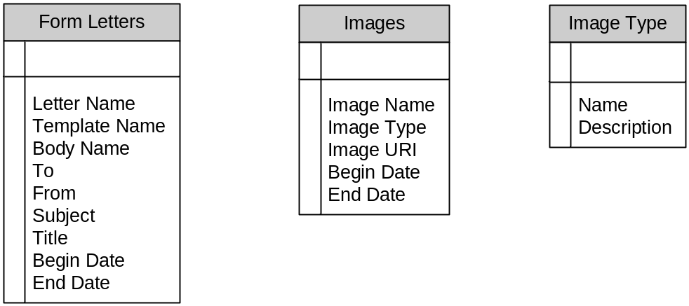

Figure 2-2. Example Logical Data Model

Normalization
The term "normalization" or "normal form" is a pillar of learning data modeling. There have been many versions of normalization proposed, studied, and implemented in many ways over the years. Most of these are far more than what is needed; and some are for theoretical exercise only. One of the simplest standards is comprised of five words:

Atomic Non-Repeating Key Dependent

This simple sentence will serve you well in learning to design simple data structures that will perform well. Let's take it one part at a time.

Atomic
This is quite simple - no field should contain a string which must be parsed to be used - things like a comma separated list.

Non-Repeating
This one is a classic mistake - "contact 1 name, contact 2 name" - you can almost guarantee that the first user needs 3 contacts. Make it a sub-table of contacts, all linked via a contact usage table back to the main record.

Key Dependent
This one is more difficult to understand in the beginning - but let me give you a simple example.
Name and Address should NEVER be in the "Person" table. If you move from one city to another, your name is the same; your eye color is the same; your height is the same - but your address changes. It isn't part of "you" which would be the key of the "Person" table. Addresses are shared by many people (everyone in your family living in the same house has the same address!). And technically, Addresses are "owned" by the postal service as they can change the street name any time they want. They can re-number as well. So again, make it a sub-table of addresses linked by an address usage table.

Usage Table
Since I mentioned it twice, let me tell you what it looks like in practice. One table holds address data (line 1, line 2, city, state, zip). One table holds address usage codes (street, mailing, home, work). One table holds People. The final table is a linking table - a "people id", "address usage code", and "address key". So the linking gives us a business result:

Louis | Mailing | 40 W. Cavallo Trail
Louis | Street | 40 W. Cavallo Trail
Rebecca | Street | 40 W. Cavallo Trail
Rebecca | Mailing | POB 12345

Figure 2-3. Example Usage Linking

Implementation View (Physical Data Model)
The final phase - as we prepare to create databases to store the business information. This is the first time that Technology enters our picture. The physical view is dependent upon the database the enterprise will use for the implementation. This view converts the Business Names from the Logical Model into Database Column Names using the class words reference in section 3 and the process in section 4. It also documents the size of the data, its existence requirements, and associates its definition.
It is strongly suggested that you follow the Verbalization Test example as you work through this phase. There is nothing more complex than making fields named things like:
"Employees.employee_date_of_birth_date" when "Employees.birth_date" will do just fine.

Table Names
Our first challenge is the structure of table names. For our purposes, we are keeping it as simple as we can. As a row in a table represents one instance of that type of data, then the table must represent a collection - and therefore, our table names will be the plural of the entity they hold.

Column Names
Column names are derived from following the process in Section 4 of this document, using the verbalization test and class words reference tables as well as the Business Glossary from the Business Analysis team.

Data Types
This is our first real mapping to the database engine which will house our data. The data types are different from the various vendors, so you must use the reference chart from the correct database vendor and version. The type may also vary based on the size of the field - 255 characters or less fits in a "TINYTEXT" field on MySQL. No need to waste a 64KB "text" field for a 30 character "name".

Size and Precision
The last part - how big is the datum? The number of characters and/or digits in a value must be defined exactly at this point. Each database has its own way, so you will have to make sure you get the details for the database you will be working with.
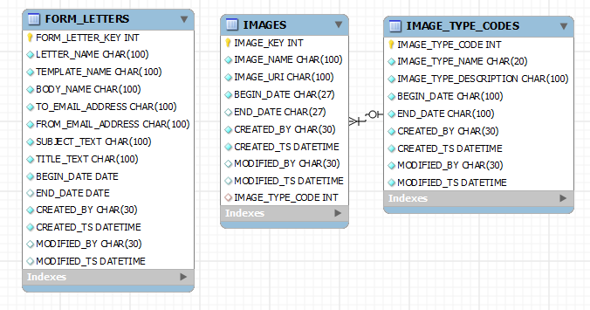

Figure 2-4. Example Physical Data Model

Reference Materials

Class words Reference Chart

Type or Usage of Data | Class word | Abbreviation
Standard Currency Fields | Amount | AMT
Generic Numeric Counter | Count | CNT
Quantity (specific type of count) | Quantity | QTY
Date | Date | DT
Description | Description | DSC
Flag (more than 2 options) | Flag | FLG
Geographic Information (GEO Code) | Geometry | GEOM
Unique Identifier | Identifier | ID
A Yes/No Indicator (boolean only) | Indicator | IND
Record Key | Key | PK/FK
Any Name Field | Name | NM
Business Fields Called "Number" | Number | NBR
Any Percentile Field | Percent | PCT
Fields containing a standard Rate | Rate | RT
Any Narrative Text | Text | TXT
Any Fields Containing Time | Time | TS
The Time Stamp on a Record | Timestamp | TS

Figure 3-1. Class words Reference

Many organizations do not use the full set of Class Words- saying that "NBR" is good enough for all - but if you have ever tried to buy a set of hardware to build a workbench, you know the fun of needing quantities of 4 bags of 25 count nuts and 2 bags of 50 count washers and 5 bags of 20 count bolts to get 100 of each - and you really learn the difference between count and quantity!

Verbalization Test

The verbalization test is quite easy - it has only 2 steps, and one goal. NO REDUNDANCY!

- Ask Out Loud:
  - “What is the value of [field name] for that [table name] ?”
- Answer Out Loud:
  - “The Value of that [table name](s) [field name] is [legal value]”

As shown here in this example:

- What is the value of Employee First Name for that Employee?
- The Value of that Employees Employee First Name is Louis
  - Well.. that’s redundant! Let’s try again...
- What is the value of First Name for that Employee?
- The Value of that Employees First Name is Louis
  - That makes Sense! Much Better!

Of course, there is also the issue of "unique" in the application. Do not repeat the entire table name in the column name - just enough of the parts of the name to make it unique.

Attribute Naming Process
For each data element in each entity, we must convert the Business Name to the Database Name. This is done by following these steps:
- change all spaces to underscores (Date of Birth becomes Date_of_Birth)
- Classify the data type and assign the relevant class word.
- Remove Redundancy
- Determine the Qualifier and apply to the field
- Determine the Prime Word and apply to the field
- Remove Redundancy
- Abbreviate if required

Classify and Class Word
Compare the business field name and description with the Class Words reference chart. Many times, "flipping" the business field name is enough to start - "Date of Birth" becomes Birth_Date.

Reduce
If adding a class word causes a redundancy (or is superfluous), remove it:
Applicant_name_name is bad; Applicant_name is good.
Applicant_name_text - not needed.

Determine Qualifier
This is an exercise in determining "which one" the field should refer to - should user_name be user_first_name? Which Amount? Invoiced_amount or Paid_amount?

Determine Prime Word
Prime words also help with making fields unique across the application. Although they map into a business object, they have a more "meta" layer standard - an example of this usage would be if several tables had a "description" field. The business Glossary would look like:
- Term: Description
  - Definition:
    - description of the alpha environment
    - description of the beta environment
    - description of the prod environment
By applying "Prime" words to the "DESCRIPTION" field, e.g. "ALPHA_DESC" and "BETA_DESC" our glossary becomes easier to read:
- Term: Alpha Description
  - Definition: description of the alpha environment
- Term: Beta Description
  - Definition: description of the beta environment

Reduce
Again, if we have injected redundant words, reduce

Abbreviate
The final part of dealing with the database - learn the size limit for column names and abbreviate as required. Start by abbreviating the class word and go from there. But do NOT abbreviate just for the sake of doing so. If it fits, leave it alone.

Upper Case
And the standard for data models is to use all upper case - so do so:
USER_FULL_NAME
WORK_EMAIL_ADDR
SECURITY_ROLE_CD
TOTAL_INVOICE_AMT
TOTAL_PAID_TO_DATE_AMT

